

School of Computer Science and Engineering (SCOPE)
COURSE PROJECT
BCSE409L – Natural Language Processing
Winter Semester 2025-26
FarmBuddy: A Multimodal and Multilingual Intelligent Assistant
for Plant Disease Detection and Agricultural Decision Support

23BCE0708 – NIRVANA DAS
23BCE0854 - MEHWISH
23BCE0905 – AARUSHI CHAUDHARY
Prof. Rajeshkannan R
Course Faculty

GitHub Repository Link : https://github.com/MEHWISH310/FarmBuddy

Abstract
India's agricultural sector holds significant importance for its economy yet farmers face persistent difficulties in accessing essential agricultural knowledge which includes information about crop diseases and market prices and government programs and crop advisory services. The current agricultural AI systems available in the market address only one particular problem through their solutions which include either plant disease detection or chatbot-based advisory systems without delivering an all-encompassing answer. FarmBuddy AI introduces a multilingual agricultural assistant which operates through one intelligent system to help farmers. The system uses Natural Language Processing (NLP) and Named Entity Recognition (NER) along with deep learning methods to enable farmers to ask questions and identify crop diseases. The backend system uses Flask REST APIs while the frontend development utilizes web interfaces built on JavaScript. The system processes voice and text input to determine user intent while extracting crop and location data which enables it to deliver market price information and government scheme details and crop advisory content and responses about plant diseases. The MobileNetV2 deep learning model uses the PlantVillage dataset for trained plant disease detection purposes. The model enables disease identification through both image and video analysis by utilizing Test Time Augmentation (TTA) and multi-frame analysis methods. The system supports 14 Indian languages which allows farmers to communicate in their most comfortable language. The experimental evaluation demonstrates that the disease detection model successfully detects plant diseases through its analysis of leaf images while the text-based disease matching system identifies potential diseases through user-provided symptom descriptions. The system provides support for various Indian languages which enables farmers to use the platform through their chosen language. The proposed system shows that farmers can obtain various agricultural services through one AI-based platform which provides services for disease identification, crop recommendations, market price data, and government program information. This development enables farmers to access agricultural information which results in improved decision-making for their farming operations.

Introduction
Background and Relevance
The Indian economy relies on agriculture to provide the basic necessities for the people who work in the field. There is a large number of farmers in India who depend on farming as a source of earning their livelihood. Farmers face difficulties in getting accurate and timely information related to farming. Farmers who live in rural areas face difficulties in getting important information related to the identification of diseases in crops, crop advisory services, government welfare schemes, etc.
Plant diseases present one of the most significant threats which lead to agricultural crop damages. Early detection of diseases enables farmers to implement protective measures which decrease harm to their crops. Farmers require assistance with their farming decisions because they need both information about government support programs and market price data and cultivation techniques. Intelligent digital systems can provide crucial information to farmers because rural areas now have better access to smartphones and internet connectivity.
Another challenge facing Indian farmers is language diversity. Indian farmers speak different languages, and existing digital agricultural platforms are designed to provide information in English language only. It becomes hard for these farmers to interact with these platforms. An agricultural assistance system that supports multiple languages and different input types will be very useful.
Review of Existing Solutions and Their Limitations
In recent years, various solutions have been proposed to help farmers. Many research works have been carried out to implement various solutions to plant disease detection using deep learning techniques. In this approach, the images of the leaves of the plants are used to detect the diseases. This approach has shown promising results. However, this approach can only be used to detect plant diseases through images.
Other research works have been carried out to implement agricultural chatbot systems. In this approach, the answers to the questions of the farmers related to the cultivation of the crops, fertilizers, etc., are given. However, this approach does not include plant disease detection through images. In recent years, various research works have been carried out to implement a combined approach of chatbots and plant disease detection. This approach has shown improvements. However, this approach does not include the functionality of supporting multiple languages, videos, etc. In addition, this approach does not include the functionality of providing various useful services such as market price, crop advisory, government schemes, etc. Most of the existing approaches can only be used to solve one or two problems.
Research Gap
On the analysis of existing systems, it is found that there is a lack of a unified platform that can offer different types of agricultural services at one time. Existing systems may be focused only on disease detection or only on providing information using chatbots.
Besides that, some existing systems may not provide the facility of multi-lingual interaction with the users, especially farmers who prefer to converse in regional languages. There is also a lack of multimodal interaction with the system using images, videos, text, and voice in a single platform.
Therefore, there is a need to design a system that can offer different types of facilities like NLP-based chatbots, disease detection, crop information, price information, and multi-lingual interaction in a unified platform called an agricultural assistant.
Objective and Proposed Solution
The main aim of this work is to design a system called FarmBuddy AI, an intelligent system that assists farmers in accessing critical agricultural information in a more efficient manner. It makes use of Natural Language Processing techniques and deep learning techniques in plant disease detection.
FarmBuddy is a system through which a farmer can interact with it using text, voice, images, and even video. It processes the queries sent by the farmers, recognizes the intention of the user, and retrieves critical entities such as crop names and relevant information related to disease detection, crop advisory, pricing, and government schemes.
It also includes multilingual support, through which a farmer can interact with this system in different Indian languages. It makes it more useful and accessible to different farmers.

Major Contributions
The major contributions of the work can be listed as follows:
- Designing a multimodal agricultural assistant that can handle text, voice, image, and video input modes under a single umbrella.
- Incorporating Natural Language Processing techniques to understand the queries of farmers and provide relevant information.
- Developing a deep learning-based plant disease detection system that can classify diseases from leaf images as well as video.
- Supporting multiple languages to communicate with farmers who speak different Indian languages.
- Incorporating multiple agricultural, including crop advisory, market information, government schemes, and disease identification.

Literature Survey
The agricultural sector is benefiting from the technology without any limitations to the various types of AI (Artificial Intelligence), ML (Machine Learning), NLP (Natural Language Processing), and the various types of advancements in deep learning. Various types of intelligent systems were developed by researchers to help farmers identify diseases affecting the crops, agricultural advisory systems, and information retrieval systems. These types of systems were developed to help farmers enhance productivity in the agricultural sector.

Overview of Traditional and Recent Methods
Traditionally, agricultural advisory systems were mainly dependent on consultations with agricultural experts and government extension agencies. The option of updation faced limited access to timely information on crop disease, fertilizers, weather updates, and market rates of crops.
Most of the artificial intelligence-based agricultural advisory systems were developed in the range of 2018-2022, focusing on plant disease detection using image processing techniques. This is the earliest of all studies, where Mohanty et al. (2016) implemented a system that makes use of deep convolutional neural networks for detection of plant disease by using images of leaves using images from PlantVillage, where high classification accuracy is achieved using deep learning techniques.
Research has been conducted to further improve this idea to enhance the model of disease detection. Singh et al. (2023) came up with a fine-tuned CNN that can be used for the detection of plant leaf diseases. This improves the classification of the diseases. In another research paper, Mishra and Singh (2023) came up with a CNN that can be used for the prediction of plant diseases. This indicates that the use of deep learning has the potential to improve the accuracy of plant disease detection.
Scientists have also attempted to make use of efficient optimization methods along with the application of deep learning models for the accurate determination of the plant diseases. A methodological approach has been proposed by Raja & Karthikeyan (2023), in which an artificial algae optimization method along with the application of deep learning models is used for the accurate categorization of plant diseases. Balafas et al. (2023) carried out an in-depth study on the application of machine learning as well as deep learning models for the accurate categorization of plant diseases. Srivastava et al. (2024) proposed the rapid detection of plant diseases through the application of AI models. Nandi et al. (2023) proposed the application of device-friendly deep learning models for the detection of guava fruit as well as plant diseases. Bhuiyan et al. (2025) as well as Reddy et al. (2025) proposed comparative as well as pathogen-based deep learning models for the accurate determination of plant diseases.
In the last few years, the researchers were primarily focused on integrating various technologies to develop smart agricultural techniques. A research proposal on the application of intelligent agricultural systems with the help of Internet of Things, cloud computing, and deep learning algorithms for the detection of plant diseases and monitoring crops was proposed by Morchid et al. (2024). Similarly, a big data-driven deep learning technique for the detection of plant diseases for precision agriculture was proposed by Elfouly et al. (2025).
A separate line of work that has been done is creating conversational systems for farmers. The agricultural chatbots have been proposed as a way of giving the farmers information on the management methods which can be made at real time. The researchers developed a chatbot system which provided answers to questions about crop cultivation practices and fertilizer applications and other farming methods according to Maduri et al. (2021). Momaya et al. (2021) developed the "Krushi" chatbot system which provides agricultural information to users.
The chatbot system development process has achieved multiple breakthroughs which include deep learning model-based improvements that enhance system functionality. The researchers developed an interactive agricultural chatbot system which uses deep learning models to improve response accuracy according to Suman and Kumar (2022). The researchers proposed an intelligent chatbot assistant which will support agricultural activities for farmers according to Biswas and Goel (2023).
The latest improvements include the addition of plant disease detection to the existing chatbot system. Mittal et al. (2024) proposed a multimodal chatbot design which can be utilized for plant disease detection implemented through appending the image classification model.
Another enhancement of the chatbot system is the incorporation of multilingual support features within the chatbot system. Srinivas et al. (2024) suggested a reinforcement learning-based chatbot system named "Raithubot," which can assist farmers with their local language, i.e., Telugu language, with the incorporation of Reinforcement Learning from Human Format (RLHF) models. Karthick et al. (2025) suggested a multilingual chatbot system named "Farm Sage," which can provide information to farmers on different topics related to agriculture and plant disease detection.
The existing smart agriculture systems received enhancements through the implementation of generative AI technology. Sai et al. (2025) explained the potential of generative AI technology in the development of Agriculture 4.0 to improve sustainable agriculture. Jadhav et al. (2025) developed a conversational AI system which offers farmers intelligent crop improvement recommendations.
Comparative Analysis and Research Gap
The current literature review shows that agricultural AI systems in use today focus on solving one specific problem which restricts their ability to deliver essential agricultural services needed by farmers who work in diverse fields.
The deep learning systems developed by Mohanty et al. (2016), Singh et al. (2023), Mishra and Singh (2023), and Raja and Karthikeyan (2023) achieve high accuracy rates when they identify plant diseases through analysis of leaf photographs. The systems depend completely on image data to function because they lack any ability to interact with users through speech and they provide no access to market data or government program information.
The systems that use chatbots for their advisory functions provide users with agricultural knowledge through written text about crop production and farming techniques. The systems do not support image or voice input which prevents farmers who have limited reading skills from using the systems while the systems also lack any ability to identify diseases.
The latest research studies work to establish links which connect two separate areas of study. Mittal et al. (2024) developed an image classifier system which they used in their multimodal chatbot while Srinivas et al. (2024) developed a multilingual chatbot which supports only Telugu language. Karthick et al. (2025) developed a system that enables Q&A in multiple languages while identifying diseases but the system has not yet solved its integration problems. The large-scale systems developed by Morchid et al. (2024) and Elfouly et al. (2025) require high computational power to operate yet their systems do not allow farmers to use their technologies directly.
The main finding shows that no present system fulfills all four fundamental requirements of farmers which include detecting crop diseases and providing market price information and delivering government scheme details and enabling farmers to receive advisory information in multiple languages. This research gap represents a major area of investigation.
To address this, FarmBuddy is proposed as a comprehensive multimodal and multilingual intelligent assistant integrating NLP, NER, MobileNetV2-based disease detection, and a structured knowledge base covering market prices, government schemes, and crop advisory across 14 Indian languages.
Literature Comparison Table
Author | Year | Method | Dataset | Limitation
Mohanty et al. | 2016 | CNN for plant disease detection | PlantVillage dataset | Only image classification
Maduri et al. | 2021 | Agricultural chatbot | Farmer query dataset | Limited interaction features
Momaya et al. | 2021 | NLP chatbot (Krushi) | Agricultural knowledge base | No image disease detection
Suman & Kumar | 2022 | Deep learning chatbot | Agriculture Q&A data | Limited real-time intelligence
Biswas & Goel | 2023 | Intelligent chatbot assistant | Agriculture domain data | No multimodal integration
Singh et al. | 2023 | Fine-tuned CNN model | Plant leaf images | Only disease classification
Mishra & Singh | 2023 | CNN-based prediction | Plant leaf datasets | Requires large datasets
Raja & Karthikeyan | 2023 | Deep learning + artificial algae algorithm | Leaf image dataset | Computational complexity
Balafas et al. | 2023 | ML/DL comparative study | Multiple datasets | No real-time advisory system
Nandi et al. | 2023 | Device-friendly deep learning | Guava fruit and leaf dataset | Single crop focus
Mittal et al. | 2024 | Chatbot + image classifier | Plant disease datasets | Limited multilingual support
Morchid et al. | 2024 | IoT + cloud + DL review | Agricultural IoT datasets | No conversational interface
Srivastava et al. | 2024 | AI-based rapid disease detection | Plant disease image datasets | Limited to image input only
Srinivas et al. | 2024 | RLHF multilingual chatbot | Telugu agricultural dataset | Limited disease detection
Jadhav et al. | 2025 | Conversational AI agriculture system | Agricultural advisory data | Limited multimodal capability
Karthick et al. | 2025 | Multilingual Q&A + disease detection | Agricultural dataset | Integration challenges
Elfouly et al. | 2025 | Deep learning + big data analytics | Large agricultural datasets | High computational cost
Sai et al. | 2025 | Generative AI in Agriculture 4.0 | Agricultural domain data | Limited practical deployment
Bhuiyan et al. | 2025 | Comparative DL models study | Plant leaf disease datasets | No real-time advisory
Reddy et al. | 2025 | Deep learning plant pathogen detection | Multi-crop plant datasets | No multilingual support
Table.1. Literature Comparison of all Reference Paper
Problem Description
Overview of the Proposed System
Agriculture serves as a vital economic engine for various developing nations especially in India where most people rely on farming to sustain their livelihoods. Farmers encounter multiple difficulties because they cannot identify plant diseases and do not possess dependable market data and they have trouble understanding foreign languages and their knowledge about government programs and farm advisory services remains limited. Small and marginal farmers face difficulties because conventional agricultural support systems present obstacles through their fragmented structure and their reliance on regional language access which makes them hard to use.
The proposed system FarmBuddy functions as an intelligent multilingual agricultural assistant because it combines natural language processing and machine learning disease detection and structured agricultural datasets to provide farmers with support during real time. The system provides farmers with various ways to communicate through text and voice and image and video which enables all users to access the platform regardless of their technical abilities.
FarmBuddy utilizes conversational AI together with image classification and video analysis and data retrieval systems to deliver farmers with practical information. Farmers can inquire about crop diseases and market prices and government schemes and crop advisory recommendations. The system enables farmers to upload crop leaf images or videos which the system uses to identify diseases through its trained deep learning model.
The system enables multilingual communication which supports 14 Indian languages to help farmers who speak different languages across various regions. The translation modules enable users to communicate in their preferred languages while the system processes all information through an English-based backend system. The system architecture of the proposed system architecture uses three distinct layers which include the Frontend Layer and Backend API Layer and Data and Model Layer to manage various system components.
System Framework
FarmBuddy's overall architecture is divided into three core layers that deal with handling user input to generate smart command responses as shown in Fig.1.
Frontend Layer
The Frontend Layer serves as a user interface for web browsers which developers created with HTML and CSS and JavaScript through the files index.html and script.js and style.css. The system allows users to enter text through its chat interface and to use voice commands through the Web Speech API and to upload single images for disease detection and multiple video frames for disease analysis. The interface supports 14 Indian languages English, Hindi, Bengali, Telugu, Tamil, Marathi, Gujarati, Kannada, Malayalam, Punjabi, Odia, Urdu, Nepali, and Kashmiri with RTL (right-to-left) layout support for Urdu and Kashmiri. The translations.js module handles all UI string translation at runtime by communicating with the /api/translate endpoint on the backend.
Backend API Layer
The Backend API Layer is implemented using the Flask web framework in Python. The core processing engine of this layer establishes communication between the frontend and the data/model layer.
The backend exposes multiple RESTful API endpoints which each handle a particular system operation. The major endpoints are shown in Table 2:
Endpoint | Method | Function
/api/chat | POST | Handles conversational queries
/api/predict-disease | POST | Performs disease detection from images
/api/predict-disease-video | POST | Performs disease detection from videos
/api/translate | POST | Handles translation of text responses
/api/price | GET | Retrieves crop market prices
/api/schemes | GET | Fetches government scheme information
/api/advisory/<crop> | GET | Provides crop-specific advisory
/api/faqs | GET | Returns frequently asked questions
/api/health | GET | Checks system status

Table.2. Major endpoints in backend
The backend system executes essential functions which enable it to handle farmer queries through successful processing and response delivery. The system begins user query analysis through natural language processing which enables it to identify user intent through subsequent intent classification. The system uses named entity recognition to identify essential details which include crop names and state information.
The backend system uses deep learning models to analyze images and videos for predicting crop diseases which it uses to perform disease-related tasks. The system fetches vital details from agricultural databases which contain market prices and government schemes and crop advisory records and translates the generated response into the user-selected language. The system achieves modular operation through dedicated endpoints which enable its functions to develop into scalable and maintainable components.
Data and Model Layer
The Data and Model Layer include all datasets and trained models used by the system. The layer stores processed Agmarknet market price data which is found in the market_prices_all_crops.csv file that contains nine crop price information from various Indian states. The system contains custom JSON datasets which provide information about crop advisory services and government schemes and frequently asked questions.
The system contains the crop-disease-symptom CSV file which includes data about different diseases (crop_diseases.csv) used for text-based disease matching. The system contains the trained MobileNetV2 model (disease_model.h5) along with its class indices (class_indices.pkl) which enables image and video-based disease prediction across 38 different disease categories.
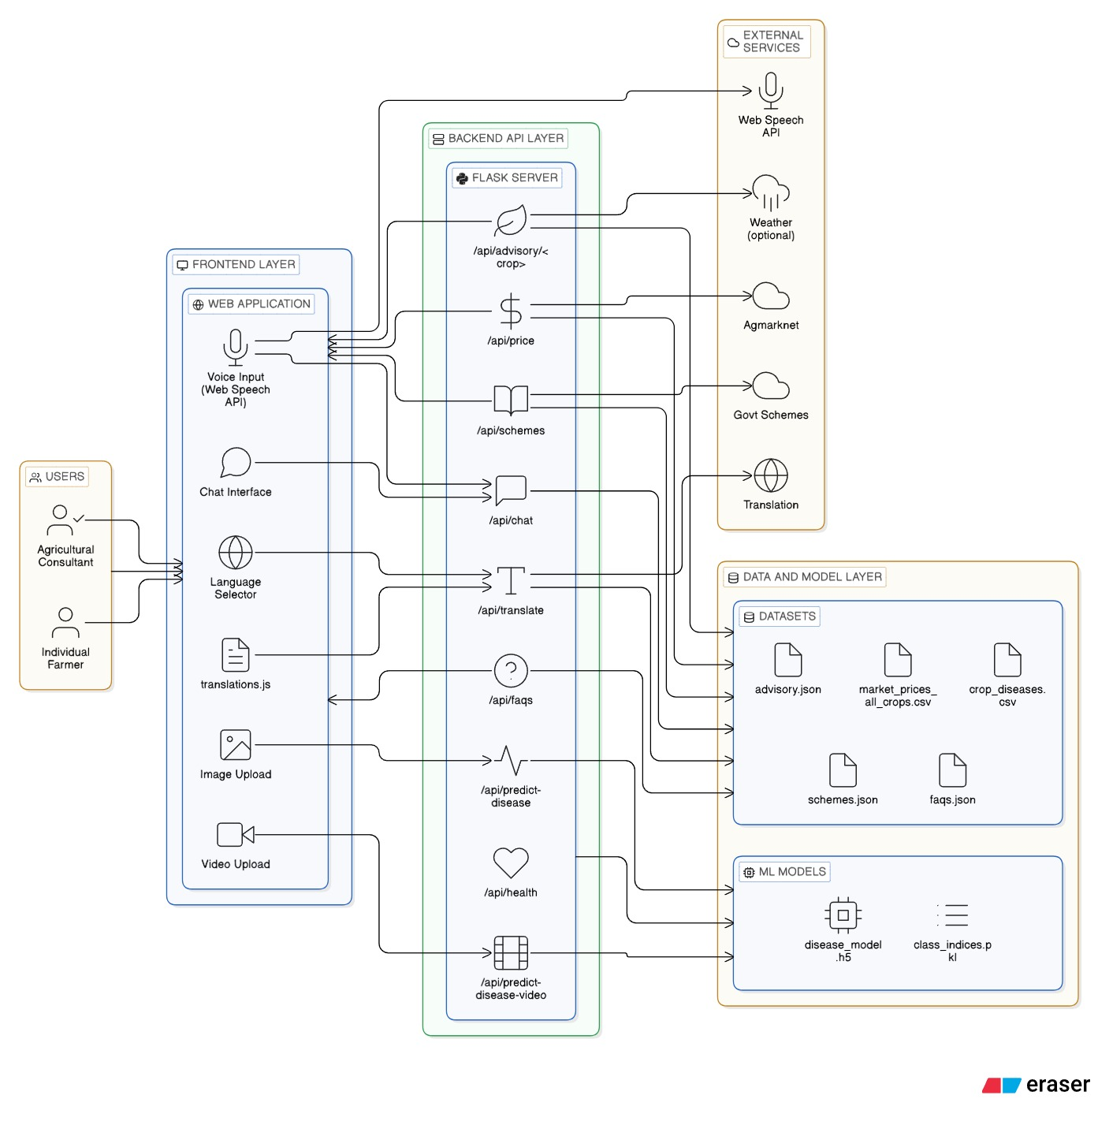
Fig.1. System Framework
Pseudocode of the Proposed System
The following pseudocode describes the core algorithm used in the /api/chat pipeline for processing
farmer queries:
Chat Processing Algorithm
INPUT: user_query, ui_language
STEP 1: Language Translation
english_query, detected_language = translate_to_english(user_query)
STEP 2: FAQ Matching
tokens = remove_stopwords(english_query)
IF price_keywords not present:
FOR each faq in FAQ_dataset:
score = token_overlap(tokens, faq.tokens)
IF top_score >= threshold:
RETURN translated_faq_answer
STEP 3: Intent Classification
IF keywords match price category:
intent = "market_price"
ELSE IF keywords match scheme category:
intent = "scheme"
ELSE IF keywords match advisory category:
intent = "advisory"
ELSE IF keywords match disease category:
intent = "disease"
ELSE:
intent = "general"
STEP 4: Entity Recognition
crop = detect_crop(english_query)
state = detect_state(english_query)
STEP 5: Intent Handling
IF intent == market_price:
response = get_crop_price(crop, state)
IF intent == scheme:
response = retrieve_government_schemes()
IF intent == advisory:
response = retrieve_crop_advisory(crop)
IF intent == disease:
response = match_disease_symptoms(english_query)
IF intent == general:
response = greeting_or_help_message()
STEP 6: Response Translation
IF ui_language != English:
response = translate(response, ui_language)
STEP 7: Return Response
RETURN JSON(response, intent, detected_language)
Image Disease Prediction Algorithm
INPUT: image_file
STEP 1: Load trained MobileNetV2 model
STEP 2: Preprocess Image
resize image to 224x224
normalize pixel values
expand dimensions
STEP 3: Run Prediction
prediction = model.predict(image)
disease_class = argmax(prediction)
confidence = max(prediction)
STEP 4: Treatment Lookup
treatment = search_treatment_dictionary(disease_class)
STEP 5: Return Result
OUTPUT = {disease, confidence, treatment}
Video Disease Prediction Algorithm
INPUT: video_file
STEP 1: Extract key frames from video
frames = extract_frames(video, 20)
STEP 2: For each frame
apply test-time augmentations
run prediction on augmented frames
average predictions
STEP 3: Filter predictions
keep predictions with confidence >= 0.40
STEP 4: Aggregate results
compute weighted confidence scores
select disease with highest score
STEP 5: Return final disease prediction
System Flow
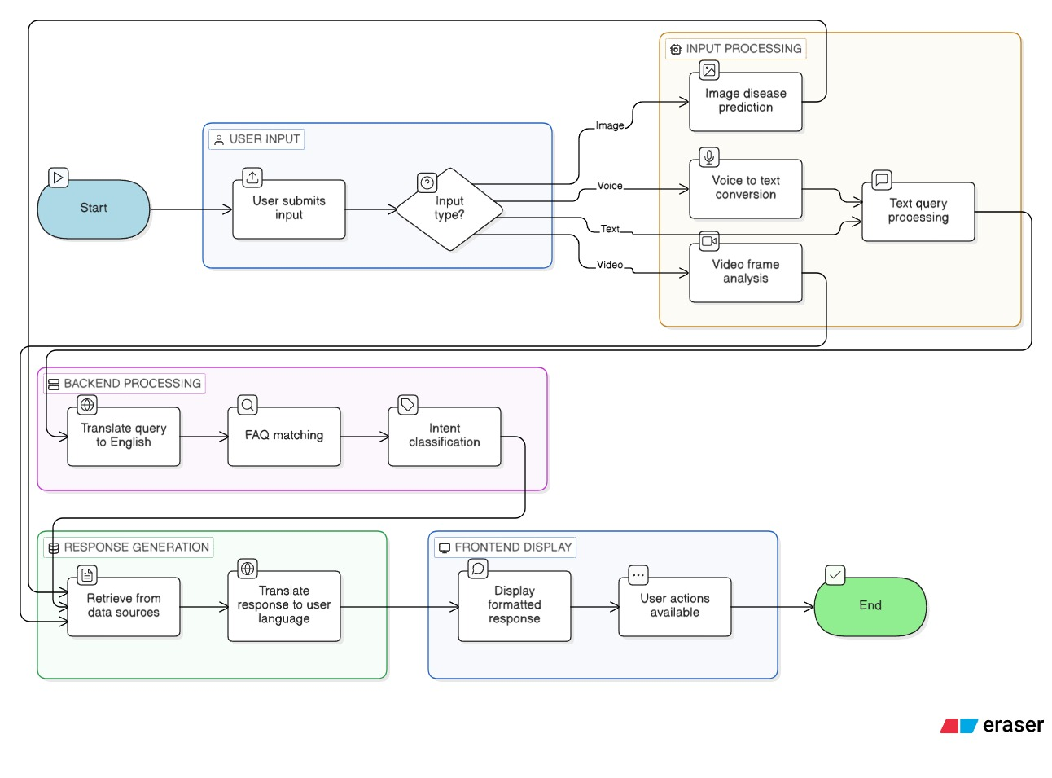
Fig.2. Flow Diagram of the System
As shown in Fig.2, the following describes the complete end-to-end system flow from user input to response delivery:
- The user submits a query through the browser-based frontend via text voice image or video input.
- The Web Speech API transcribes spoken user queries into text when users select their preferred language for voice input.
- The frontend uses POST requests to send image data to the /api/predict-disease endpoint. The backend runs DiseasePredictor.predict() and returns the disease name confidence score and treatment recommendation.
- The frontend uses POST requests to send video data to the /api/predict-disease-video endpoint. The backend extracts 20 key frames and applies TTA across 5 augmentation variants per frame and aggregates predictions using confidence² weighted voting to produce the final disease result.
- The system processes text and voice queries by sending both the query and the chosen language code to /api/chat through a POST request.
- The backend system first translates the user query into English before it conducts FAQ matching through price query bypass and then it identifies the user's intent before extracting named entities which include crop and state names.
- The appropriate intent handler generates a response from the corresponding data source the market price CSV, government schemes JSON, crop advisory JSON, or the text-based disease symptom matcher.
- The generated response is translated into the user's selected language if it is not English, using the Google Translate-based translation module.
- The frontend receives the JSON response and renders it as a formatted chat message with support for copy to clipboard, text-to-speech playback, bookmark, and share actions.
Experiments
Datasets
The four separate datasets which make up FarmBuddy AI operate different functional components of the system.
PlantVillage Dataset (Kaggle): The PlantVillage dataset from Kaggle serves as the main dataset which trains the plant disease detection model. The library includes 54305 labeled crop leaf images which show both healthy and diseased condition across 38 different categories that include 14 different crop types. The system uses RGB images which exist at different resolution levels and converts them into 224×224-pixel size through its preprocessing procedure. The system uses multi-class classification with deep learning methods to classify each class which represents a unique crop-disease combination.
Agmarknet Market Price Data: The official Indian government platform for agricultural market information Agmarknet provided access to government agricultural market price data. The data was available for download in CSV format which included 9 crops: Almond, Arhar Dal, Bajra, Barley, Onion, Potato, Rice, Sunflower, and Wheat. The record consists of fields that include State District Market Commodity Arrival Date Min Price Max Price Modal Price and Arrival Quantity. The research team used individual CSV files which contained data for each crop and created a unified processed file named market_prices_all_crops.csv to support efficient runtime data querying.
Crop Disease CSV (Custom): The dataset contains more than 250 records which describe various crop diseases and their associated symptoms. The dataset contains six fields which include crop, symptom_description, possible_disease, cause, detailed_explanation, and treatment_solution. The dataset includes 12 crop types which are Tomato, Potato, Apple, Corn, Grape, Peach, Pepper, Raspberry, Soybean, Cherry, Blueberry, and Orange. The six disease categories include Fungus, Bacteria, Virus, Pest, Nutrient Deficiency, and Abiotic. The text-based DiseaseMatcher module requires this dataset for its operation but it does not serve any purpose in model development.
Custom JSON Datasets: Three custom JSON files were developed to enable the advisory systemand the FAQ system to function properly. The file crop_advisory.json presents structured agricultural guidelines which cover essential requirements for major Indian crops, including their planting season and soil needs and irrigation methods and fertilizer usage. The file schemes.json provides information about government welfare programs which include PM-KISAN and PM Fasal Bima Yojana and Kisan Credit Card scheme. The file faq_dataset.json contains common farmer questions which have been paired with structured answers and keyword tags that enable FAQ matching.
Dataset Sample
The following tables present a sample of the custom crop disease CSV dataset used for text-based
disease detection and Agmarknet market price dataset after preprocessing:

Crop | Symptom Description | Disease | Cause | Treatment (Brief)
Tomato | Leaves with dark concentric rings and yellow halos | Early Blight (Alternaria) | Fungus | Apply chlorothalonil; mulch; rotate crops
Potato | Dark brown lesions on leaves with white fungal growth on margins | Late Blight (Resistant Strain) | Fungus | Apply mefenoxam; destroy infected plants
Apple | Leaves with olive green spots turning brown and corky | Apple Scab (Venturia) | Fungus | Apply fungicides from green tip; rake leaves
Corn | Leaves with long gray green lesions turning tan with dark borders | Northern Corn Leaf Blight | Fungus | Plant resistant hybrids; apply fungicides at tasseling
Soybean | Rust coloured pustules on lower leaf surfaces | Soybean Rust (Tropical) | Fungus | Apply fungicides preventatively at flowering
Table.3. Sample Crop Disease CSV data extracted from PlantVillage dataset
Commodity | State | District | Min Price (Rs./Q) | Max Price (Rs./Q) | Modal Price (Rs./Q) | Arrival Date
Onion | Maharashtra | Pune | 90 | 2200 | 950 | 01-03-2026
Wheat | Punjab | Fazilka | 2450 | 2610 | 2520 | 25-02-2026
Rice | West Bengal | Darjeeling | 4700 | 4900 | 4800 | 01-03-2026
Potato | Uttar Pradesh | Agra | 400 | 900 | 550 | 27-02-2026
Bajra | Rajasthan | Jaipur | 1600 | 5380 | 1850 | 28-02-2026
Table.4. Sample Agnmarket Dataset for Market Price
Preprocessing and Data Cleaning
Image Preprocessing:
The PlantVillage dataset requires its images to undergo preprocessing through PIL which prepares them for MobileNetV2 model input. The preprocessing process requires resizing images to 224×224 pixels and converting them to RGB format and normalizing their pixel values to the range of [0, 1]. The Keras ImageDataGenerator uses various training augmentations which include 20-degree rotation and 0.2 width-height shifts and 0.2 shear transformation and 0.2 zoom and horizontal flip. The validation process uses 20% of the data while 80% of the data remains available for training purposes.
Market Data Cleaning:
The Agmarknet raw CSV files contain multiple inconsistencies because they include comma-separated numeric values and missing entries and mixed date formats. The MarketDataCleaner module removes commas from price columns and transforms the data into float format while it uses pandas coercion to manage missing arrival quantity data and it establishes DD-MM-YYYY format for arrival dates and it introduces a download_date column. The pandas concatenation method enables the joining of all cleaned individual files into one unified CSV file which gets organized according to arrival date.
Model Training Parameters:
The MobileNetV2 base layers remain frozen throughout the initial training period to maintain the ImageNet weight distribution. The model uses the Adam optimizer with a learning rate of 0.001 to train for 20 epochs while using categorical cross-entropy loss and a batch size of 32. The system uses three callbacks which include EarlyStopping that has a 5-patience setting to stop overfitting and ReduceLROnPlateau which reduces learning rates by 0.2 after 3-patience periods and reaches a learning rate minimum of 0.00001 and ModelCheckpoint which saves only the best validation accuracy weights.
Text Disease Matcher Scoring Parameters:
The DiseaseMatcher module applies a weighted scoring system which ranks disease records based on the user's symptom description. The scoring system assigns weights to different matching elements which include crop name exact match which provides 30 points and crop token overlap which gives 12 points for each matching token and symptom token overlap which gives 5 points for each matching token with a maximum of 40 points and visual descriptor keyword matches which provide 3 points for each match with a maximum of 15 points and cause synonym matches which provide 7 to 10 points and disease name token overlap which gives 10 points for each matching token with a maximum of 20 points. A score of 10 or higher allows a record to become a matching candidate while a score of 30 or higher shows high confidence in one result.

Results and Discussion
Disease Detection Model Performance
FarmBuddy AI uses MobileNetV2 deep learning architecture with transfer learning for its plant disease detection system. The model was trained using the PlantVillage dataset, which contains labeled images of plant leaves representing various diseases and healthy conditions. The dataset includes 38 plant disease classes, which cover multiple crops and multiple disease types.
The dataset was divided into two parts during training, which included 80% for training and 20 percent for validation purposes. The neural network received images after researchers resized them to 224 × 224 pixels and performed normalization processes. The training process lasted for 20 epochs, during which researchers tracked both training accuracy and validation accuracy results.
The model showed strong results after reaching a training accuracy of about 89% and a final epoch validation accuracy of about 94% as shown in Fig.3. The model shows strong generalization abilities because its validation accuracy exceeds its training accuracy, which indicates that overfitting has not occurred.
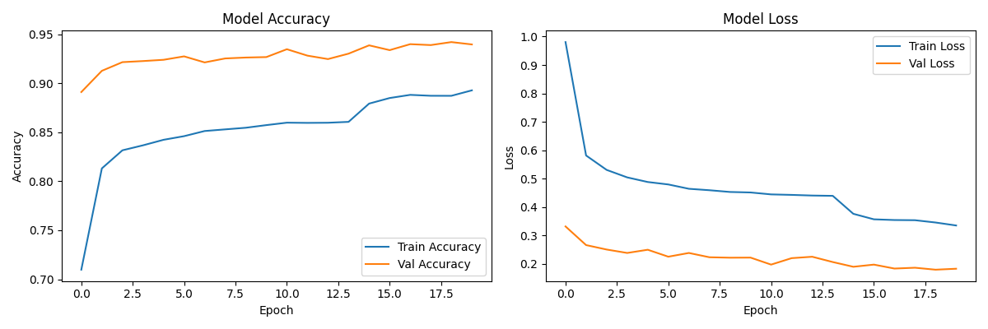
Fig.3. Training and Validation Curves of Plant Disease Detection Model
The accuracy curve shows continuous training accuracy improvement throughout all epochs. The model learns disease patterns from the dataset according to this accuracy pattern. The validation accuracy shows improvement until it reaches a stable point during the final epochs. The loss curves show training loss and validation loss both decrease at a constant rate which indicates that the model parameters learn effectively and optimize successfully.
The final performance metrics obtained from the trained model are summarized in Table 5:

Metric | Value | Important Note
Training Accuracy | 89% | On 80% split of PlantVillage
Validation Accuracy | 94% | On 20% split of PlantVillage
Training Loss | 0.34 | Final epoch training loss
Validation Loss | 0.18 | Final epoch validation loss
Number of Classes | 38 | Disease + healthy plant classes
Model Architecture | MobileNetV2 + Custom Dense Layers | Transfer learning approach
Image Input Size | 224 × 224 px | RGB normalized
Training Epochs | 20 | Model convergence achieved
Table.5. Performance Metrics of Trained Model
These results demonstrate that the MobileNetV2 architecture is effective for plant disease
classification tasks. The relatively low validation loss indicates good model generalization and stability.
Text-based Disease Matching Performance
FarmBuddy AI includes an image-based disease detection system together with its function that permits users to identify diseases through written text. The module enables farmers to use natural language queries for describing their plant symptoms. The system uses a symptom-based matching algorithm which exists in the NLP module (disease_matcher.py) to match symptoms with their most probable disease outcome.
The system evaluated 50 sample farmer queries which described various plant symptoms. The system successfully identified the correct disease in 44 out of 50 cases, resulting in an accuracy of approximately 88% for the top predicted disease. The correct disease appeared in 48 out of 50 cases when evaluating the top three predicted diseases which resulted in a top-3 accuracy of approximately 96%. The performance showed particular strength for tomato and potato and apple crops which have complete disease records available in the dataset.
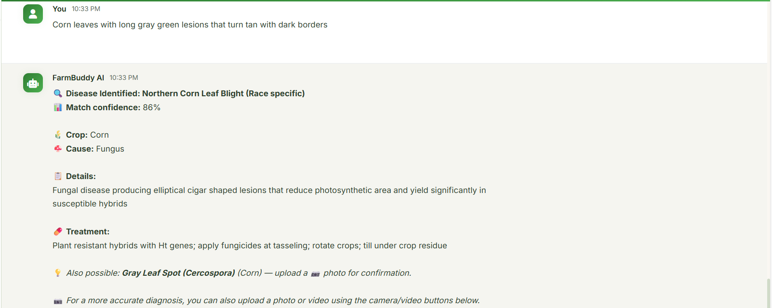
Fig.5. Example output of the text-based disease matching system
Market Price Query Performance
The FarmBuddy AI system also provides farmers with access to market price information for agricultural crops using data retrieved from the Agmarknet dataset. This module processes user queries to extract crop names and locations using a Named Entity Recognition (NER) approach.
The system was evaluated using 30 crop price queries covering 9 different crops across multiple Indian states. The results indicate that the crop name extraction module correctly identified crop names in 29 out of 30 queries, while the state extraction module correctly identified states in 27 out of 30 queries.
Price information was successfully retrieved for 26 out of 30 crop-state combinations. The remaining cases failed because the requested crop price data was unavailable for the specified state in the dataset.
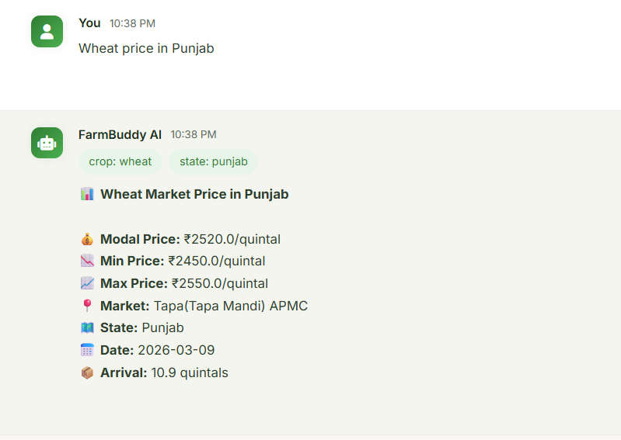
Fig.6. Example output of the market price query system
Multilingual Support
FarmBuddy AI provides multilingual query support to enhance accessibility for farmers throughout India. The system uses language detection and translation modules to handle user queries which are written in various Indian languages. The system allows farmers to communicate with it through their chosen languages so they do not need to understand English.
The system currently supports 14 languages, including English, Hindi, Bengali, Telugu, Tamil, Marathi, Gujarati, Kannada, Malayalam, Punjabi, Odia, Urdu, Nepali, and Kashmiri. The language detection module detects and translates the query into English for processing by the backend modules. The system translates the produced response back into the language that the user originally used.
The testing for multilingual queries demonstrated that the language detection module accurately identified the correct language in most instances while the translation output effectively communicated agricultural information which included disease diagnosis and crop advisory and market price details. The system delivers responses within an acceptable timeframe despite translation delays which add minimal waiting time.
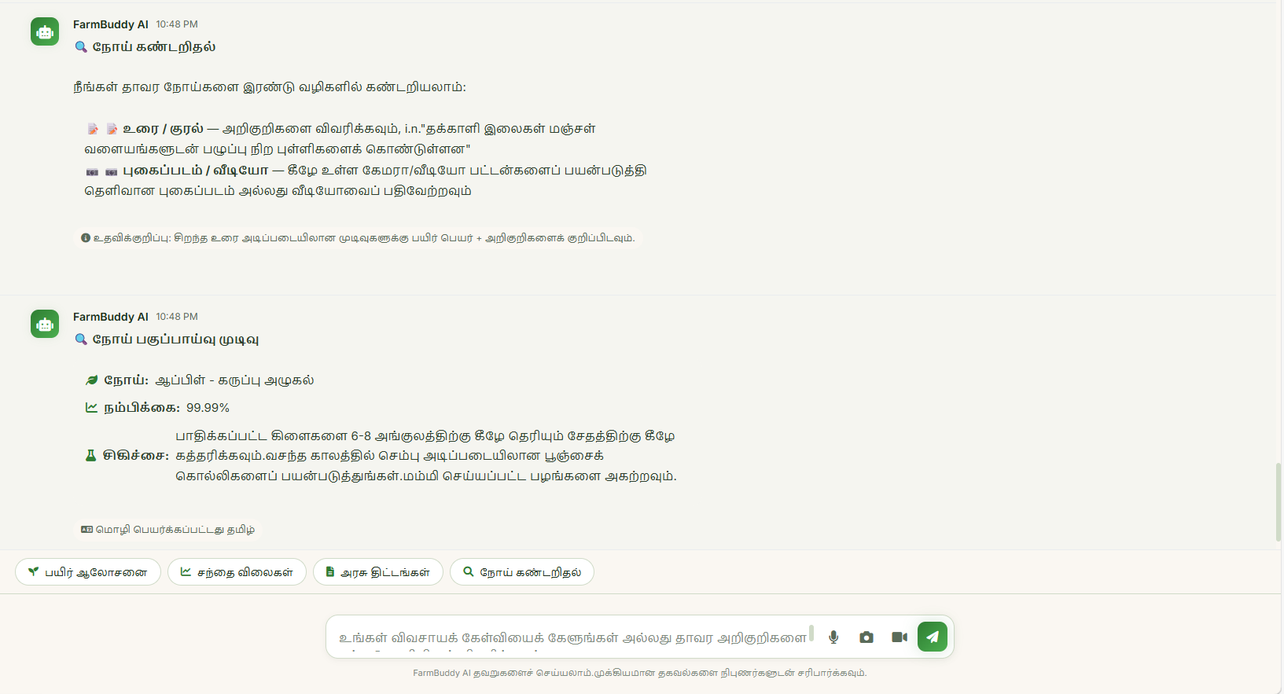
Fig.6.1. Example demonstrating query in Tamil
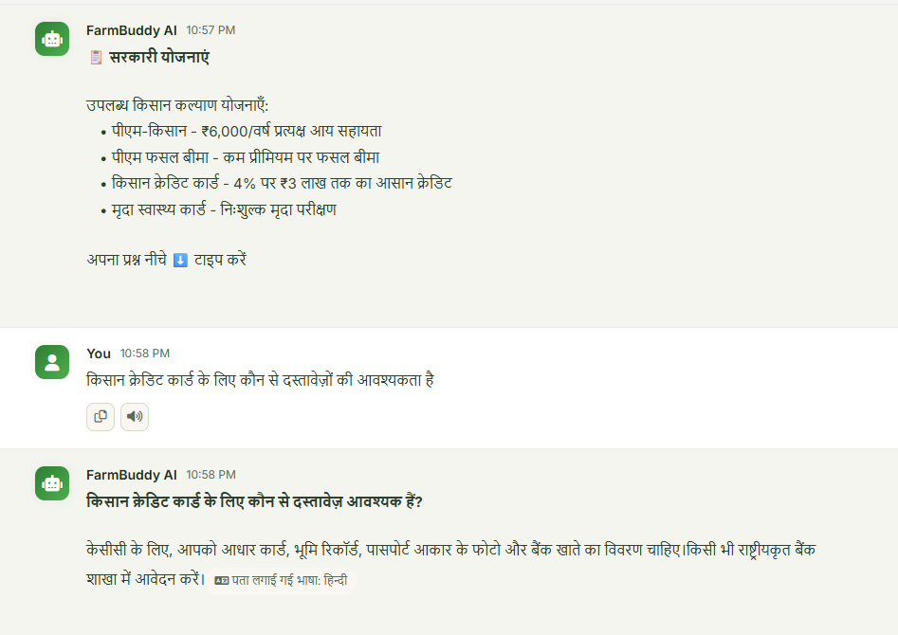
Fig.6.2. Example demonstrating query in Hindi
Confusion Matrix Analysis
To further evaluate the classification performance of the plant disease detection model, a confusion matrix was generated using the validation dataset. The confusion matrix, as shown in Fig.4 provides a detailed visualization of how accurately the model predicts each disease category.
The confusion matrix shows that most predictions land on the matrix diagonal. The model achieves accurate plant disease classification for most disease categories. The system shows only a few off-diagonal values which indicate minor errors that occur between visually identical diseases.
Various diseases that impact identical crops can exhibit similar visual characteristics which include leaf spots and discoloration and mildew structures that sometimes cause misidentification. The MobileNetV2 model demonstrates effective learning of unique visual attributes which enables it to separate different plant diseases while maintaining accurate classification results.
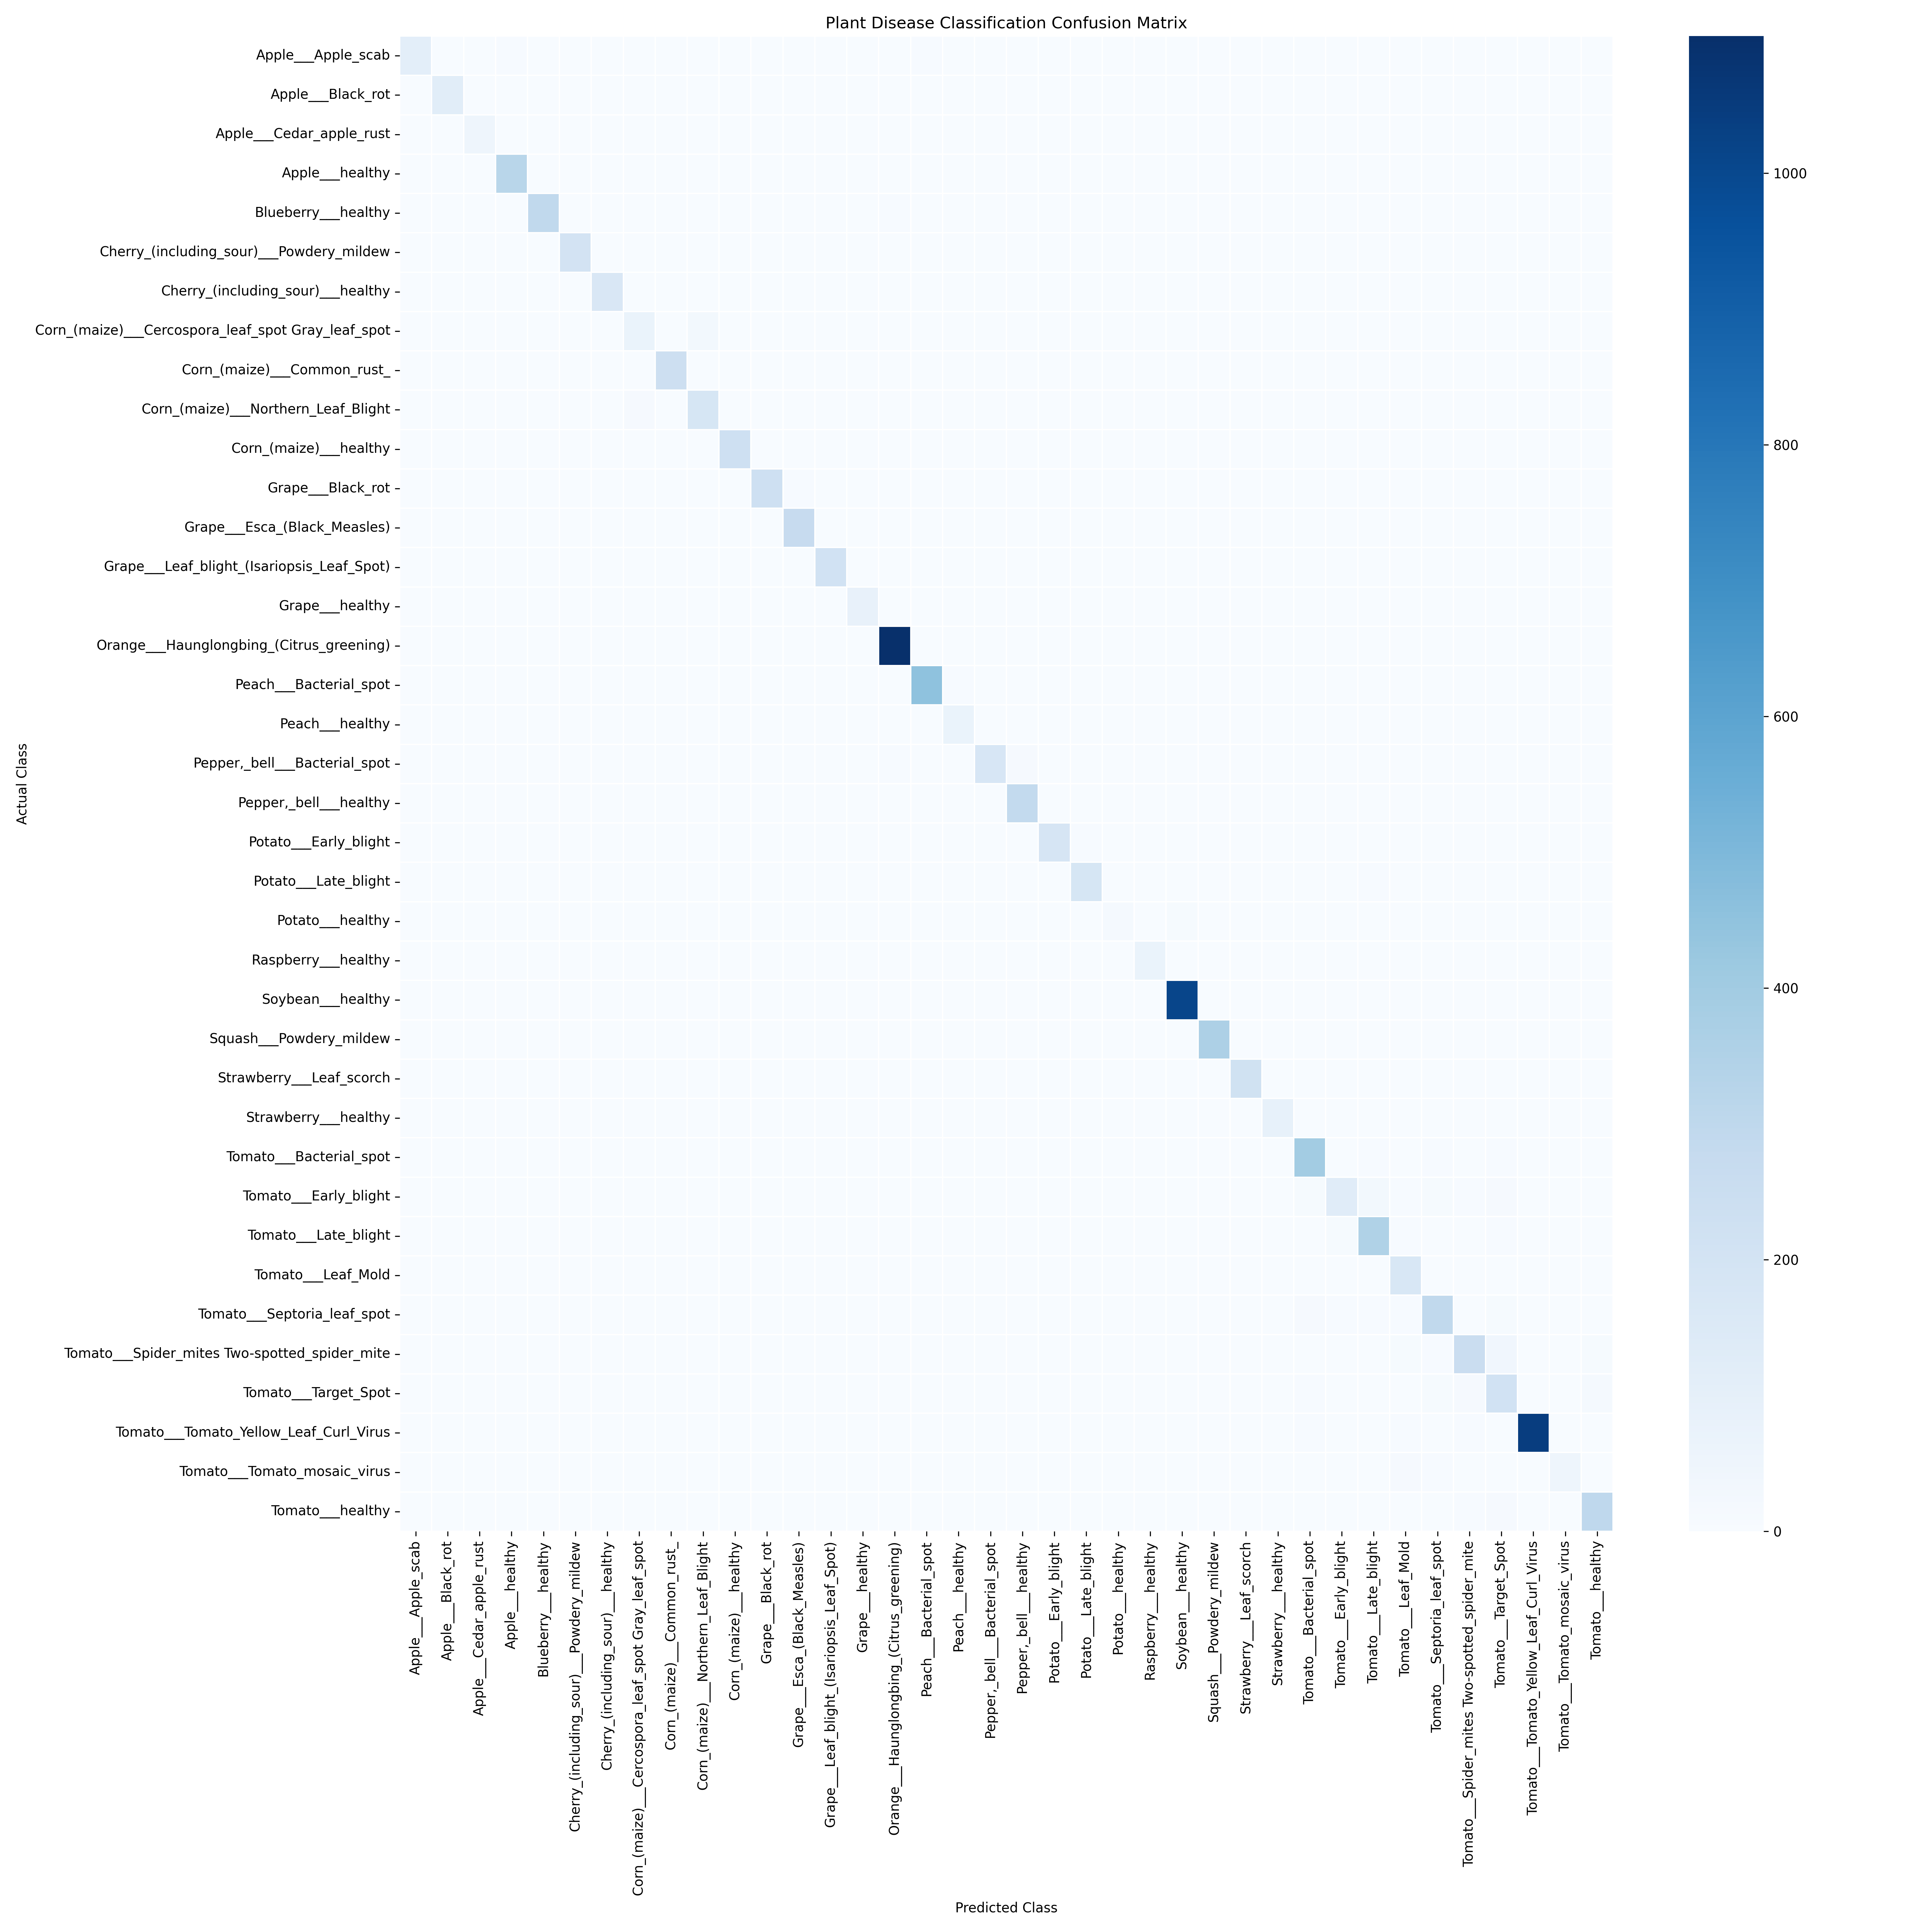
Fig.4. Confusion matrix representing classification performance across 38 plant disease classes
Conclusion and Future Work
This paper introduced FarmBuddy AI which serves as a complete agricultural assistant that operates through multiple sensory channels and supports multiple languages to assist Indian farmers. The system combines multiple advanced technologies which include Natural Language Processing (NLP) for intent classification and Named Entity Recognition and a multi-factor text-based disease matching system and a MobileNetV2 deep learning model for image-based disease detection and real-time market price analysis through Agmarknet data and multilingual translation across various Indian languages. The system functions through a Flask REST API which supports a browser-based frontend that allows farmers to access the system without needing to install any mobile application.
The disease detection model achieved a validation accuracy of approximately 94% on the PlantVillage dataset across 38 plant disease classes which showed its ability to identify multiple crop diseases through analysis of leaf images. The text-based disease matching module achieved 88% top-1 accuracy and 96% top-3 accuracy when evaluated on sample farmer symptom queries. The system functions as a multilingual platform which enables farmers from different language groups to access market price information and receive crop advisory services and obtain information about government schemes.
The FarmBuddy AI solution solves a critical challenge which exists in current agricultural AI systems that only operate through single functions intended for either disease detection or market analysis. The system of FarmBuddy AI delivers complete agricultural support which includes disease identification and market research and professional recommendations and multilingual communication through one platform.
The upcoming research will center on enhancing the disease detection system through training which will utilize actual field visual data to create better detection capabilities for agricultural environments. The system will achieve better performance through various enhancements which include increasing the market price database to include additional crops and locations and adding current weather information to create location-based crop recommendations and developing vocal interaction features through text-to-speech technology which helps farmers with low reading skills and building compact models for use in areas with poor internet access and adding support for more regional languages.

References
Balafas, V., Karantoumanis, E., Louta, M., & Ploskas, N. (2023). Machine learning and deep
learning for plant disease classification and detection.
IEEE Access. https://doi.org/10.1109/ACCESS.2023.3324722
Bhuiyan, Z. W., Limon, M. H., Rana, M. R., et al. (2025). A comparative study of deep learning
models for plant leaf and disease recognition. In ICACTCE 2024.
Springer. https://doi.org/10.1007/978-3-031-94623-3_40
Biswas, R., & Goel, N. (2023). Intelligent chatbot assistant in agriculture domain. In Agriculture-
Centric Computation (ICA 2023).
Springer. https://doi.org/10.1007/978-3-031-43605-5_14
Elfouly, M. K., AbdelAziz, A. M., Gomaa, W. H., et al. (2025). A deep learning-based framework
for large-scale plant disease detection using big data analytics in precision agriculture.
Journal of Big Data. https://doi.org/10.1186/s40537-025-01265-9
Jadhav, A. N., More, P. B., & Prasad, K. K. (2025). A conversational AI solution for smart
agriculture and enhanced crop performance. In ICACTCE 2024.
Springer. https://doi.org/10.1007/978-3-031-94623-3_43
Karthick, J., Reddy, M. B., Karthick, L., & Eswari, A. (2025). Farm Sage multilingual agricultural
Q&A assistant and plant leaf disease detection. In International Conference on Smart Structures and Systems. IEEE. https://doi.org/10.1109/ICSSS66939.2025.11346384
Maduri, P. K., Dhiman, P., Shukla, M. R., Anand, S., & Singh, S. P. (2021). Farmers agriculture
assistance chatbot. In International Conference on Advances in Computing, Communication Control and Networking. IEEE. https://doi.org/10.1109/ICAC3N53548.2021.9725634
Mishra, R., & Singh, D. (2023). Convolutional neural network method for effective plant disease
prediction. In IEEE International Conference on Integrated Circuits and Communication Systems. https://doi.org/10.1109/ICICACS57338.2023.10099559
Mittal, S., Upadhyay, T., Avasthi, K., Singh, A. A. S., & Pachchigar, A. (2024). Multi-model
chatbot and image classifier for plant disease detection. In Advancements in Smart Computing and Information Security (ASCIS 2023).
Springer. https://doi.org/10.1007/978-3-031-58604-0_15
Mohanty, S. P., Hughes, D. P., & Salathe, M. (2016). Using deep learning for image-based plant
disease detection. Frontiers in Plant Science. https://doi.org/10.3389/fpls.2016.01419
Momaya, M., Khanna, A., Sadavarte, J., & Sankhe, M. (2021). Krushi - The farmer chatbot. In
International Conference on Communication Information and Computing Technology.
IEEE. https://doi.org/10.1109/ICCICT50803.2021.9510040

Morchid, A., Marhoun, M., El Alami, R., et al. (2024). Intelligent detection for sustainable
agriculture: A review of IoT-based embedded systems, cloud platforms, DL, and ML for plant disease detection. Multimedia Tools and Applications.
https://doi.org/10.1007/s11042-024-18392-9
Nandi, R. N., Palash, A. H., Siddique, N., & Zilani, M. G. (2023). Device-friendly guava fruit and
leaf disease detection using deep learning. In Machine Intelligence and Emerging Technologies.
Springer. https://doi.org/10.1007/978-3-031-34619-4_5
Raja, D., & Karthikeyan, M. (2023). Automated plant leaf disease classification using artificial
algae algorithm with deep learning model. In International Conference on Sustainable Computing and Data Communication Systems. IEEE. https://doi.org/10.1109/ICSCDS56580.2023.10104602
Reddy, K. K., Limje, S. M., Naga Malleswari, T. Y. J., & Ushasukhanya, S. (2025). PlantPath:
Deep learning-based plant pathogen detection. In International Conference on Computing and Communication Networks. Springer. https://doi.org/10.1007/978-981-96-3942-7_42
Sai, S., Kumar, S., & Gaur, A. (2025). Unleashing the power of generative AI in agriculture 4.0 for
smart and sustainable farming. Cognitive Computation.
https://doi.org/10.1007/s12559-025-10420-6
Singh, G., Guleria, K., & Sharma, S. (2023). A deep learning-based fine-tuned CNN model for plant
leaf disease detection. In IEEE Global Conference for Advancement in Technology. https://doi.org/10.1109/GCAT59970.2023.10353487
Srinivas, J., Prashanth, U. S., Malapaka, A., & Amulya, V. (2024). Raithubot: An RLHF-fine-tuned
Telugu chatbot for farmers. In Data Science and Applications.
Springer. https://doi.org/10.1007/978-981-99-7820-5_32
Srivastava, A. K., Chauhan, S., Mishra, T., & Mishra, V. (2024). Rapid plant disease detection
using AI techniques. In IEEE International Conference on Computing, Power and Communication Technologies. https://doi.org/10.1109/IC2PCT60090.2024.10486272
Suman, S., & Kumar, J. (2022). Interactive agricultural chatbot based on deep learning. In
Intelligent Data Communication Technologies and Internet of Things.
Springer. https://doi.org/10.1007/978-981-16-7610-9_70

